JESMS
Parent Handbook Addendum Effective: July 22, 2020

This has been a time unlike any other in our lives. COVID-19 has suddenly and significantly shifted education in the state of Florida. As we navigate a new learning environment, a need for innovative resources to support learning exists. We support high-quality educational opportunities for the students in our care, such that we can ensure no child is disadvantaged by the current COVID-19 pandemic and that our school is moving into and throughout next year and beyond. The school has worked diligently to develop a reopening strategy that allows for flexibility and transparency- keeping two main priorities in mind:

  - Safety of our students, faculty, and staff
  - Providing the highest caliber education where your child is nurtured, loved and empowered

Two Contingency Plans are Prepared for the 2020-2021 School Year
Plan 1: In-person learning for all students

- Classroom will provide as much space between students and teachers as is feasible during the day.
- Distance will be enforced to 3- 6 feet of social distancing during primary instructional time in the classroom and safety measures put into place.

Plan 2: Distance Learning

Full-time Virtual Learning through Distance Education
- Distance Learning will be done by using the platform Teams
- No extra-curricular activities are provided for virtual learners
- Students must wear the uniform of the school they are enrolled in during the school day
- Students may use their own device or will be provided one by the school
- Parents are required to participate in an orientation for virtual learning conducted by the school
- Parents are expected to make sure students are attending school on a daily basis
- Students are expected to attend class every day by following daily class schedule
- For some cases Distance Learning will happen only until the Fall Semester

HEALTH & SAFETY REQUIREMENTS

Social Distancing
Social distancing (also called physical distancing) means keeping space between yourself and other people outside of your home. Social distancing is a critical tool in decreasing the spread of COVID19. In this plan, JESMS staff will create as much space between individuals as possible during the day.

Requirements for Plan 1
Create social distancing floor and seating markings in waiting and reception areas

Mark 6 feet of spacing to remind students and staff to always stay 6 feet apart in lines and at other times they may congregate ( arrival and dismissal, restrooms, etc.)

Arrival and dismissal will be monitored to ensure students go straight from vehicle to their classroom, and vice versa

Nonessential visitors, volunteers, and activities involving external groups or organizations will be restricted

Sick room for students exhibiting COVID-like symptoms

Face Covering
JESMS recognizes the evolving recommendations from the CDC, AAP, and the health department and will continue to gain a clearer understanding approaching the 2020-2021 school year. Students will be expected to bring a face covering to school every day. They will be asked to wear their face covering when physical distancing is not possible. Many students will choose (or need) to wear face coverings all day. We understand that prolonged use of face coverings could be difficult and even inappropriate for some students (especially our younger students), and we hope to provide flexibility based on meeting physical distancing criteria.

Students who test positive for COVID-19
It will be important for the school to have knowledge if anyone has tested positive for
COVID-19, resides with someone who has tested positive for COVID-19, and/or has come in direct contact within a 14-day period with someone who has tested positive for COVID-19. Tracing diagnosed cases within our school community will allow us to have a better understanding of the overall school-wide health condition, localized to campus, building, and classroom.

Resurgence of COVID-19
In the unlikely event that our local community experiences a spike in COVID-19 cases and an interruption of on-campus learning occurs, we will be prepared to shift to Remote Learning for all students immediately and effectively. The goal is to make this transition for students and parents as seamless as possible. All students will remain home and instruction will be delivered remotely through technology platform (Teams).

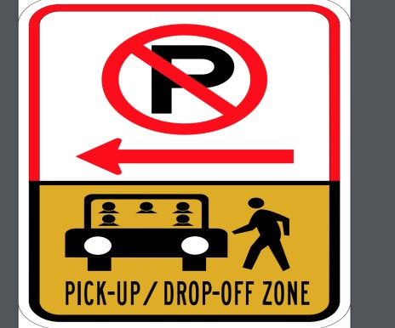
Drop-Off and Pick-Up
- Health, well-being, and temperature check before entering school
- Dismissal will be done via Walkie Talkie in an effort to maintain social distancing
- Distancing markers will be placed on walkways
- Staff and students with any illness must stay home

Health Screening at Entry
Ask the parents or guardians the following Doe your student have any of the following symptoms

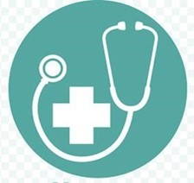
- A cough
- Shortness of breath or difficulty breathing
- A fever of 100.4°F or higher
- A sore throat
- Chills
- New loss of taste or smell
- Muscle or body aches
- Nausea/vomiting/diarrhea
- Congestion/running nose – not related to seasonal allergies
- Unusual fatigue
- Does anyone in your household have any of the above symptoms?
- Has your student been in close contact with anyone with suspected or confirmed COVID?
- Has your student had any medication to reduce a fever before coming to school?

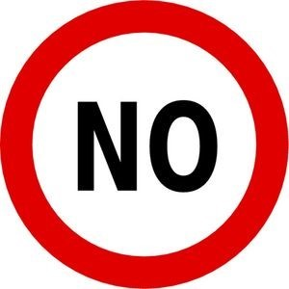
The student must be excluded from school if the answer to any of the above questions is “yes.”

Movement around School
- All non-essential movement around school will be avoided
- Reduce the number of students in the halls and bathrooms at one time
- Stagger release of classes
- Limit activities where multiple classrooms interact
- Teachers move from classroom to classroom and not students

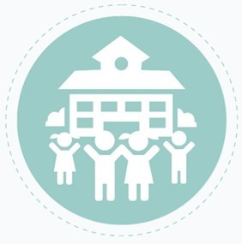
Classroom
- Staff and students trained in the areas of physical distancing, handwashing, respiratory etiquette and mask use to mitigate exposure
- Disinfect desks, keyboards, and screens
- Schedule desk sanitation during school day at appropriate transitions
- Routine cleaning of highly touched surfaces throughout the day and evening

Masks or face shields will be available for students (We anticipate that these will be worn in some manner throughout the semester. We are fully aware that the lower grade students will not be able to wear these in school and have a “normal” class)

Desks

- All desks to be faced towards one direction
- Increase the space between desks
- Rearrange students’ desks to maximize the space between students

Hygiene
- Increased hand washing
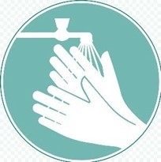
- Integrate good hygiene practices into instruction, classroom expectations and procedures
- Increased hand sanitizing stations
- Limit the use of shared materials and spaces
- Keep students’ belongings separate
- Avoid sharing supplies
- Avoid sharing electronic devices, toys, books, and other games or
- learning aids
- Avoid sharing of music instruments
- Avoid outside food in the classroom
- Students and staff use personal water bottles and water bottle filling stations vs. hallway/classroom drinking fountains
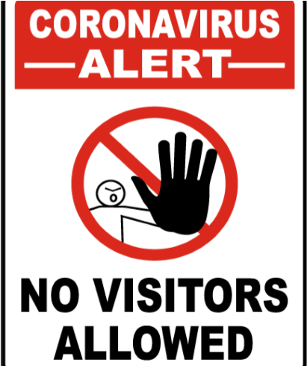

Visitors
- Post Stop The Spread signs at entry points to school and in highly visible areas
- All campus visitors will be required to use face masks while in our building
- No irregular/unscheduled visitors
- Limit visitors to parents, by appointment, and critically important visitors on campus
- Doors will be locked during school hours
- Students who are being picked up early, will be escorted out

Faculty & Staff Precautions
- Employees will be required to wear a face covering upon entering the buildings and whenever social distancing is not possible
- Masks and/or face shields available for staff members to wear
- Health, well-being, and temperature check stations

COVID-19 Planning

Isolation and Transportation of Potentially Affected:

Potentially affected individual will be transported out of the building to the designated Covid-19 area with adults’ supervision until transportation arrives within the required hour. Students, staff, teachers and administrators with confirmed Covid-19 case will not be allowed on campus. A 14-day confinement period will be applied along with a negative Covid-19 test are required in order to be allowed back into the building. All areas used by a sick person will be closed off and will not be used until after cleaning and disinfecting.
Cleaning and Disinfecting:
The following procedures will be used if someone in the building becomes affected. Close off areas used by the person who is sick. Open outside doors and windows to increase air circulation in the area. Clean and disinfect all areas used by the person who is sick, such as offices, bathrooms, common areas, shared electronic equipment like tablets, touch screens, keyboards, and remote controls. When EPA-approved disinfectant are not available, alternative disinfectants will be used (for example, 1/3 cup of bleach added to 1 gallon of water, or 70% alcohol solutions). All disinfectants will be kept out of the reach of children.

Notifying Staff and Families:

While maintaining confidentiality of the person affected with Covid-19, staff and families will be notified via phone calls, emails. Advice will be given to those who have had close contact with a person diagnosed with COVID-19 to stay home, self-monitor for symptoms, and follow CDC guidance if symptoms develop.

