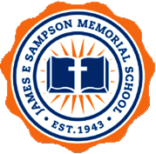
The James E Sampson Memorial SDA School
3201 Memory Lane
Fort Pierce, FL 34981
772-465-8386
Strategic Plan
Year #1: 2019-2020
Our Mission:
The James E. Sampson Memorial SDA School (JESMS) will provide a Christ-centered, academic education that empowers students with the wisdom, knowledge, and determination to reach their full God-given potential. With the caring partnership of parents and faculty, as well as the support of the Florida Conference of SDA, school leadership strives to guide our students to discover their gifts and develop an awareness of their civic responsibilities and rights for service to God, country, and the community.

Our Vision:
It is our aim to be recognized as the premier Christian school in the Fort Pierce area of Florida for developing exemplary Christian young people who are prepared to impact this world while preparing for the one to come.

Our Core Values:
Seventh-day Adventist values are rooted in the revelation of God provided through the Bible and the life of Jesus Christ. Our sense of identity and calling grows from an understanding of Bible prophecies, especially those concerning the time immediately preceding the return of Jesus. At our school, we firmly believe: each student is valued and is capable of success.

INTRODUCTION AND PURPOSE
The James E. Sampson Memorial SDA School (JESMS) located in Fort Pierce, Florida is named in honor of a former student, James E. Sampson, has a rich history of ministry committed to providing an excellent education that prepares students for service in this world and eternity. The school began at the Macedonia SDA Church on Delaware Ave. The school did not have an adequate playground, so James and his classmates were taken on a field trip to Orange Avenue in Fort Pierce for recess. The grounds were unprotected and without surrounding fences. During a ballgame, 8-year old James ran out to retrieve a ball and a tragic accident ensued by a passing automobile. James’ family and friends in great sorrow, but with great vision and selflessness, organized a community effort to make sure that this tragedy would not be repeated. In a coordinated effort, nine acres of land was purchased that eventually became the beautiful campus of the James E. Sampson Memorial Seventh Day Adventist School. JESMS is a warm and caring school whose mission is to encourage a holistic approach to education within an atmosphere that fosters education excellence. JESMS is a part of the SDA school system whose primary goal is to provide opportunities for students to accept Christ as their Savior, allow the Holy Spirit to transform their lives, and to fulfill the commission of preaching the gospel unto all the world.

GOALS and OBJECTIVES
Goal #1 - Enrollment: The James E Sampson Memorial SDA School will be known throughout the Eastern region of Florida, specifically the Fort Pierce area, as the school of choice for students in VPK through 8th grade. It is a plan to increase the current enrollment. TARGET MAY 2020

- Objective #1: Create and implement a targeted and robust communications and marketing program to improve community perception and increase enrollment.
- Objective #2: Refresh and update JESMS’s brand to better reflect the school’s message and strategic approach.
- Objective #3: Empower JESMS’s community (parents, church members, and faculty) to be brand ambassadors and thought leaders to help promote and share the school’s story and mission.
- Objective #4: Develop clear enrollment selection guidelines outlining admissions criteria for families who will honor and contribute to the school’s vision, mission, and values statements.
- Objective #5: Collaborate with local church Secretaries and Home and School leaders to create a formal focus group to aid recruitment and increase school enrollment.
- Objective #6: Create and improve opportunities for school visibility. For example:
- Revisit and enhance the school’s website
- Create and publicize a general school newsletter with input from school faculty and staff.

Goal #2 - Academic: JESMS’s will ensure the delivery of a consistently high-quality educational program and teachers. TARGET MAY 2020

- Objective #1 –Review relevant data to increase student achievement.
- Objective #2 – Examine current resources with faculty to build on or enhance the program to meet the needs of all learners.
- Objective #3 - Incorporate technology at all levels to improve student achievement**
- Objective #4 – Provide tools for measurably increase student achievement.

Goal #3 - Financial Sustainability: JESMS’s will have a financial sustainability plan to support the bold vision for its growth and future. The financial strength of the school is the backbone for the achievement of its strategies. JESMS will develop and maintain a disciplined and vibrant financial structure directly aligned with the plans and initiatives of the school. TARGET MAY 2020

- Objective #1 – Develop and maintain a multi-year financial strategic plan, and that ensure the achievement of both near-term and long-range goals and objectives.
- Objective #2 - Establish a sound financial structure that ensures self- sufficiency and sustainable growth.
- Objective #3 – Provide an infrastructure to support and manage to expand auxiliary income streams and fundraising activities.
- Objective #4 – Assist in the development of sound strategies to enhance the increase in student enrollment.
- Objective #4 – Promote and prepare timely and accurate financial reports.
- Objective #5 – Guide in the effective and efficient recording and use of all funds.

Goal #4 – Spiritual Growth: JESMS’s focus on spiritual growth will be evidenced in student commitment and a public desire to be a part of God’s remnant people. TARGET MAY 2020

- Objective #1 –Model spiritual maturity and encourage personal growth among students.
- Objective #2 – Develop and deliver a robust and personal Bible instructional program on every level at the school.
- Objective #3 – Work on developing a mentoring program designed to help youngsters become mature Christians.
- Objective #4 – Include a weekly Chapel program in the school schedule led by the pastor and/or his designee.

Goal #5 – Create a continual feedback loop between the school board, the Florida Conference, parents, and the community. TARGET MAY 2020 and before

- Objective #1 - Utilize scheduled and unscheduled meetings to share and collect information
- Objective #2 – Exploit the use of newsletters and other written correspondence to share events and activities
- Objective #3 – Promote a structure to ensure that every effort is employed to return calls, emails, and other contacts – even if to reschedule.

SUMMARY
Devising a quality strategic plan is a prudent measure to safeguard that the school is united by a common purpose. This plan is created to confirm that the key stakeholders have a shared understanding of the school’s direction to improve and continue this progress through expressed strategies. It should be understood that this a living document, and that information contained here is gathered via current and planned opportunities, and there are built-in evaluation and a review process to help the school continue to improve. What we have done within this document is to articulate James E. Sampson Memorial SDA School’s vision, mission, values, and goals. We have tried to articulate what would be best for student growth by focusing on current student trends, talent, curriculum, teacher quality, and preparation, as well as support from the school board. We have achieved this planning by reviewing what student and faculty improvement and school success would look like and how they will be attained.

CONCLUSION
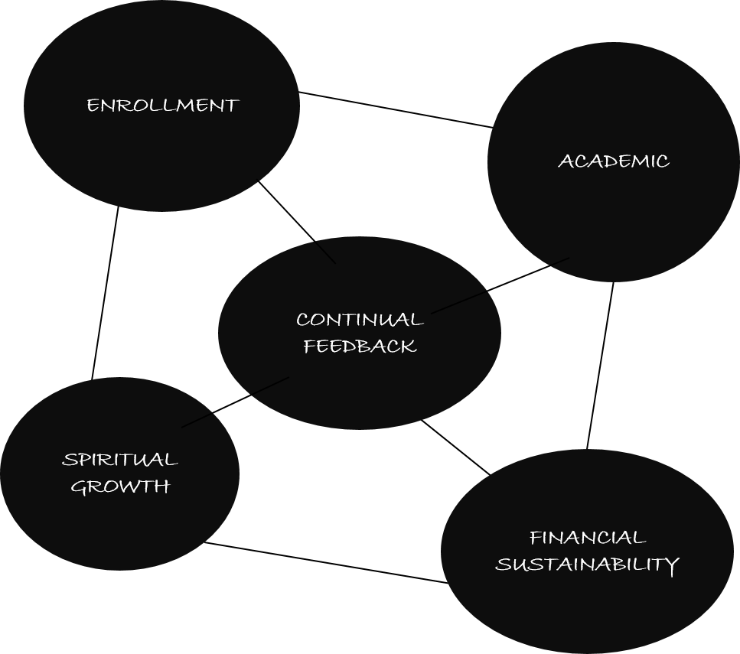

During year #1 (2019-2020) of the strategic plans, the school will concentrate on these five areas:
1. Noticeable Academic Achievement
2. Financial Stability
3. Spiritual Growth
4. Enrollment
5. Providing Continual Feedback

KEY ACTION OBJECTIVE:

SCHOOLWIDE-IMPROVEMENT ACTION PLAN

OBJECTIVE: To develop and realize this formal Marketing Plan

VISION: To be recognized as the premier Christian school in the Fort Pierce area of eastern Florida for
developing exemplary Christian young people who are prepared to impact this world while preparing
for the one to come.

ACTION STEP # | INDIVIDUAL RESPONSIBLE | ACTION STEPS | DATE/TIME | NEEDED RESOURCES
1. | Constituent/Non-Constituent  Church Pastors  VBS Leaders  Children Ministry Leaders  Adventurers & Pathfinders  Leaders  Home & School Director | Provide the school with an accurate database of all potential school age children in their churches and ministries each month.  A School Board Marketing Rep assigned will get this info. | Each month  Repeat yearly | N/A  (Home and School leaders and Education Secretaries from each church)
2. | Financial Committee and  School Board | Provide a yearly advertising budget for materials and publications. | Yearly | $800
3. | Principal, teachers, Home and School Director, Education Secretaries, Board Chair | Contact each listed family a minimum of 3 times per year, and at least once in person for recruiting purposes. | Yearly | N/A
4. | Marketing Task Force | Update website, Upkeep Facebook account to include news and events. Radio announcements, printed ads, include community leaders. | Monthly | $1000
5. | Teachers, Students, & Alumnus | Create a YouTube video with interviews, etc. tours of the school, etc. | Yearly | N/A
6. | Principal, Teachers, Students, Alumnus – Home and School Directors and Education Secretaries from all churches | Promote school within the community.  Include students and staff in various special day programs. | Bi-monthly | N/A

Working with all stakeholders and the Master Teacher we can accomplish and by far supersede benchmarks and levels we have set. “With us, as with Israel of old, success in education depends on fidelity in carrying out the Creator’s plan. Adherence to the principles of God’s work will bring as great blessings to us as it would have brought the Hebrew people.” Education, p. 50

“In our institutions of learning there was to be exerted an influence that would counteract the influence of the world, and give no encouragement to indulgence in appetite, in selfish gratification of the senses, in pride, ambition, love of dress and display, love of praise and flattery, and strife for high rewards and honors as a recompense for good scholarship. All this was to be discouraged in our schools. It would be impossible to avoid these things, and yet send them to the public schools, where they would daily be brought in contact with that which would contaminate their morals. All through the world, there was so great a neglect of home training that the children found at the public schools, for the most part, were profligate, and steeped in vice.” The Review and Herald, January 9, 1894.

